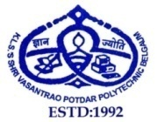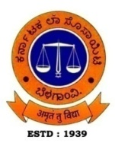**KARNATAK LAW SOCIETY’S**

**SHRI VASANTRAO POTDAR POLYTECHNIC**

**KLS CAMPUS, TILAKWADI, BELAGAVI – 590 006**

(Recognized by Govt. of Karnataka & Approved by AICTE, New Delhi)

**DEPARTMENT OF MECHANICAL ENGINEERING**

**NEWS LETTER: 2020-21 (AUGUST 2020 – JULY 2021)**

**Vision**

The department of mechanical engineering shall stand out as a benchmark for quality education by imparting technical and entrepreneurial skills to the students, to cater the ever-changing demands of the industry and societal needs.

**Mission**

To train the students of department of mechanical engineering to take up the challenges of emerging trends by empowering them with technical knowledge and entrepreneurial spirit

**Message from Chairman**

At VPP our quest for excellence continues through various initiatives that will help our students place themselves on a career path, that does justice to their capacities and motivation. I look forward for your suggestions and ideas for raising the bar.

**-Shri. U.N.Kalkundrikar**

**Message from Principal**

To impart quality education and bridge the industry-institution gap, VPP has established a Centre of Excellence which runs programmes to cater the needs of the students. Memorandum of understanding with the industries is established which helps the students in persuading internship programmes.

To help students get admitted in reputed Engineering colleges, VPP conducts NATA and DCET classes for the students of final year. Your suggestions are most welcome.

**-Ms. Shridevi S. Malaj**

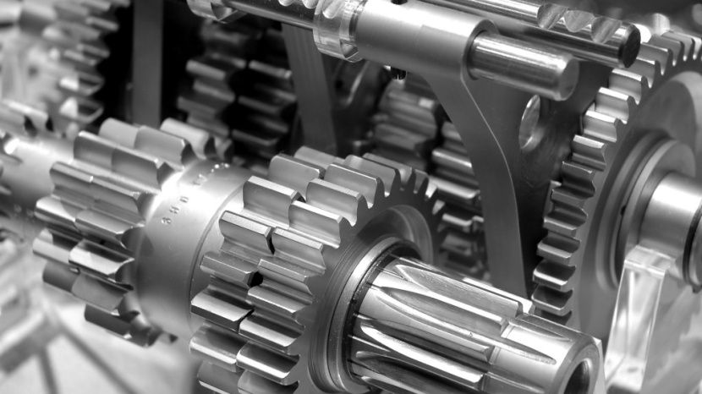

**Editorial Board**

Mr. Prathamesh P. Gurjat(HOD, ME)

Mr. Somnath K. Jathar

Mr. Arvind Badiger

**DEPARTMENT ACTIVITIES 2020-2021**

* **”Resume Building”** activity for all final year students was conducted by Placement Co-ordinator Mr. Sudhindra Kulkarni in the month of February 2021 at BASG Hall.
* A orientation program was Conducted for Final year as well as Pre-Final year students on the topic **“Career opportunities in Marine Engineering”** by Mr. Sunay Pai ,Assistant Director in the month of June 2021.
* Under the banner of **Entrepreneural Club**, Prof. Somnath K. Jathar of Mechanical Engineering Department gave a talk on **“Entrepreneurship as a career”**, Prof. S. H. Bhagavati of Mechanical Engineering Department gave a talk on **“Business opportunities in Industry”**. Prof. Prathamesh P. Gurjar of Mechanical Engineering Department gave a talk on **“Setting up a food business”** in the month of February 2021.
* Department organized online Alumni  Webinar on 27/06/2021 on the topic of **'Career  Guidance'** by Mr. Preetam Chougale . He gave  knowledge to the final year students about the topic **“After Diploma What next?”** He addressed regarding higher education, self employment and Govt. and Private opportunities after completion  of Diploma Mechanical Engineering course.

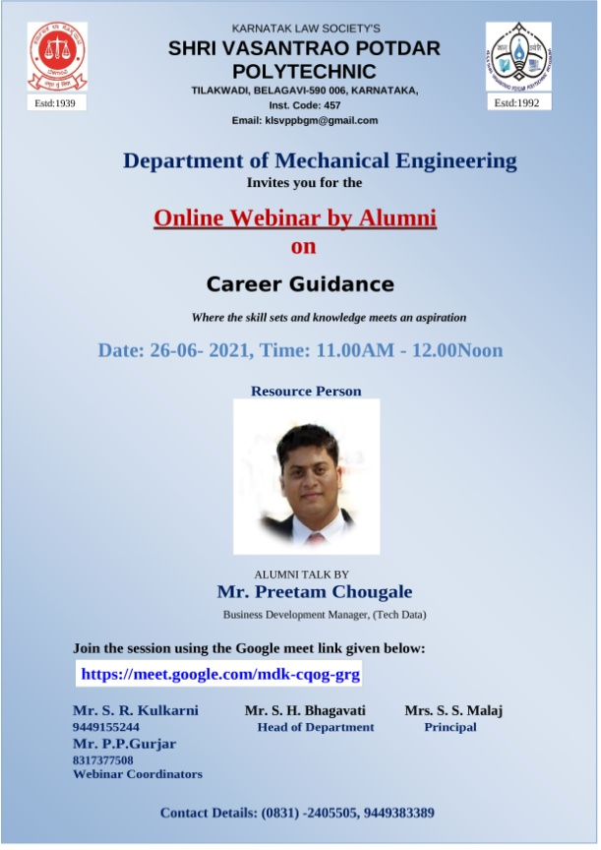

**DEPARTMENT TOPPERS FOR ACADEMIC YEAR 2020-2021**



**STAFF ACHIEVEMENTS/ACTIVITIES**

* Mr. Somnath K. Jathar Completed ATAL online FDP on “3D Printing and design” conducted by Vallurupalli Nageshwar Rao Vigana Jyothi Institute of Engineering and Technology Hyderabad in the month of February 2021.
* Mr. S. K. Jathar faculty in the department of Mechanical Engg. completed 8 weeks online course on “Student Psychology” from June to August, 2021 conducted by NITTTR, Chennai and scored 100% marks in proctored exam
* Mr. Somnath K. Jathar Successfully completed six weeks online training on “3D printing” from Internshala Trainings in the month of March-April 2021 and scored 100% marks in the final assessment and is a top performer in training.
* Mr. Somnath K. Jathar completed six weeks online training on “Machine Learning” from Internshala Trainings in the month of March-April 2021.
* Mr. Somnath K. Jathar Participated and Completed ATAL online FDP on “Innovation Management for Nurturing Entrepreneurship Culture in Educational Institutes” conducted by Bombay College of Pharmacy in the month of June 2021.

**THANK**

**YOU**