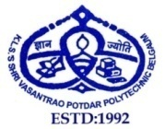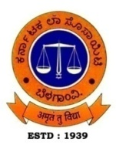**KARNATAK LAW SOCIETY’S**

**SHRI VASANTRAO POTDAR POLYTECHNIC**

**KLS CAMPUS, TILAKWADI, BELAGAVI – 590 006**

(Recognized by Govt. of Karnataka & Approved by AICTE, New Delhi)

**DEPARTMENT OF MECHANICAL ENGINEERING**

**NEWS LETTER: 2021-22 (AUGUST 2021 – JULY 2022)**

**Vision**

The department of mechanical engineering shall stand out as a benchmark for quality education by imparting technical and entrepreneurial skills to the students, to cater the ever-changing demands of the industry and societal needs.

**Mission**

To train the students of department of mechanical engineering to take up the challenges of emerging trends by empowering them with technical knowledge and entrepreneurial spirit

**Message from Chairman**

At VPP our quest for excellence continues through various initiatives that will help our students place themselves on a career path, that does justice to their capacities and motivation. I look forward for your suggestions and ideas for raising the bar.

**-Shri. U.N.Kalkundrikar**

**Message from Principal**

To impart quality education and bridge the industry-institution gap, VPP has established a Centre of Excellence which runs programmes to cater the needs of the students. Memorandum of understanding with the industries is established which helps the students in persuading internship programmes.

To help students get admitted in reputed Engineering colleges, VPP conducts NATA and DCET classes for the students of final year. Your suggestions are most welcome.

**-Ms. Shridevi S. Malaj**

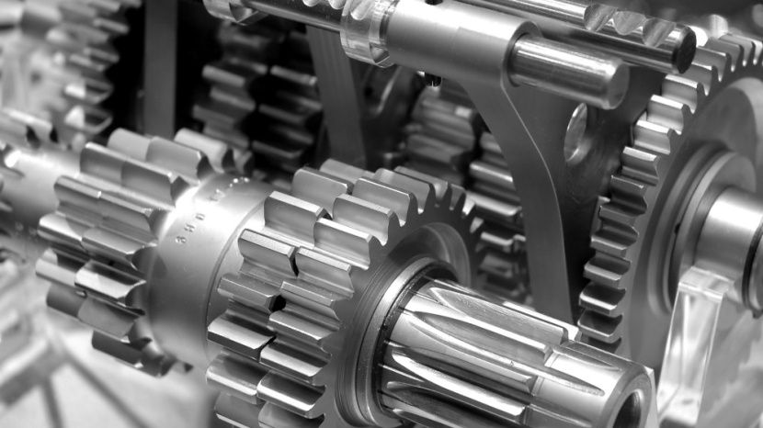

**Editorial Board**

Mr. Prathamesh P. Gurjar

Mr. Somnath K. Jathar

Mr. Arvind Badiger

**DEPARTMENT ACTIVITIES 2021-2022**

* Students of mechanical engineering completed add on course CATIA V5 from CADD Center in the month of April. 2022 in KLSVPP Computer Center.
* Students of 4th and 6th semesters visited “Project Exhibition” held at Department of Mechanical Engineering, GIT, Udyambag, Belagavi, on 6thJuly,2022. Faculty Mr. Prathamesh Gurjar and Mr. S. R. Kulkarni accompanied the students.

**DEPARTMENT TOPPERS FOR ACADEMIC YEAR 2021-2022**



**STAFF ACHIEVEMENTS/ACTIVITIES**

* Mr. S. H. Bhagawati faculty in the department of Mechanical Engg. ,Ms. Amruta Devangavi, faculty in the department of Electronics & communication Engg. Ms. Sampada Somanache faculty in the department of Architecture participated in 5-days online Faculty Development Programme on “Inculcating Universal Human values in Technical Education” from 4th October to 8th October, 2021organized by AICTE.
* Mr. S. K. Jathar faculty in the department of Mechanical Engg. completed 8 weeks online course on “Student Psychology” from June to August, 2021 conducted by NITTTR, Chennai and scored 100% marks in proctored exam

**THANK**

**YOU**